
Richie’s Restaurant Investigation
Richie has just bought 30 new rectangular tables for his restaurant. One table can seat six people. He needs to arrange them according to two conditions.
The conditions: The tables have to be set up so that he can seat at least one group of 6, 8, 10, 12, 14, 16 and 18 people all at the same time. And he wants to seat the maximum number of people possible.
The Big Question: How should Richie arrange his tables to fulfil the conditions?
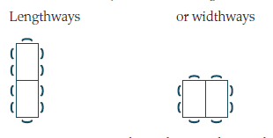
Tables can be joined two different ways.
1. How many people can be seated around two tables if they are joined together:
a) lengthways

b) widthways

2. Complete the table
Number of joined tables (t) | 1 | 2 | 3 | 4 | 5 | 6 | 7
Number of people seated
lengthways
Number of people seated Widthways

3. If Richie had no restrictions on the way he could set up his tables, what is the maximum number of people he could seat?

4. If Richie now sets up his 30 tables to fulfil the conditions, draw a seating plan on graph paper, showing your arrangement of the 30 tables. How many people can be seated using this arrangement.?

5. Consider the two ways of joining the tables in order to seat 10 people. Wich type of arrangement (lengthways or widthways) is more efficient (uses less tables)? Is this type of arrangement always more efficient?

6. Why does the way in which tables are joined together affect the number of people that can be seated around them?

7. For each of the two arrangements, write the rule that connects the number of tables (t) to the number of people that can be seated (p).

